Practice lab 1:

Dataset Names:

- Superstore Sales
- Iris
- Titanic
- Wine Quality
- Adult Census Income
- Boston Housing
- Breast Cancer Wisconsin Dataset
- Online Shoppers Purchasing Intention
- Bank Marketing
- Avocado Prices
- Amazon Top 50 Bestselling Books 2009 – 2019
- FIFA World Cup
- New York City Airbnb Open Data
- World Happiness Report
- Stock Price

Download the datasets as per the roll numbers given above and answer the questions given for corresponding datasets. Use Excel Data Analysis for this assignment.

While uploading to Moodle, please mention your dataset name, list all its column names, include the questions given, and provide answers for each question, incorporating formulas and charts as needed. Upload your results in a PDF format.

A Sample is given below:

- Amazon Top 50 Bestselling Books 2009 – 2019

The dataset includes the following variables:

- Name - The title of the book.
- Author - The name of the book's author.
- User Rating - The average rating of the book as provided by Amazon users.
- Reviews - The total number of reviews the book has received on Amazon.

- What is the average rating of the books?
Formula: =AVERAGE(Book_table[User Rating])
Answer: 4.3
- What is the distribution of the number of reviews received by the books?
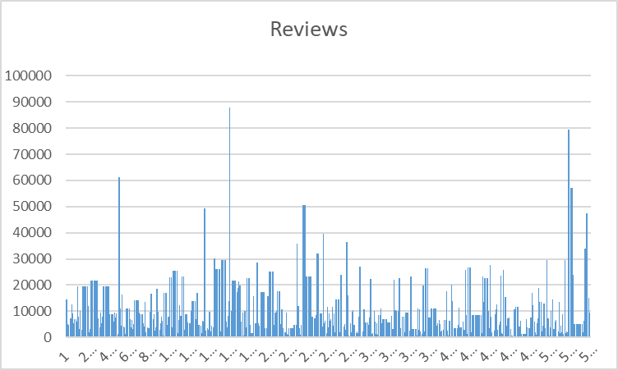
- Which book has the highest price?
- What is the correlation between the rating and the price of the books?
- What is the distribution of the genres of the books?

Questions to be answered for each datasets are:
Superstore Sales
What is the total revenue generated by the store?
Which category of products contributes the most to sales?
How has the sales trend been for the past year?
Which region has the highest sales and which one has the lowest?
What is the average profit margin of the store?
Iris
What is the distribution of each species of iris in the dataset?
What is the correlation between petal length and petal width?
What is the average sepal length for each species of iris?
Which species of iris has the largest petal area?
How many observations are there for each species of iris?
Titanic
What is the survival rate of the passengers?
What is the average age of the passengers?
What is the proportion of male and female passengers?
Which class of passengers had the highest survival rate?
What is the distribution of the fare paid by the passengers?
Wine Quality
What is the correlation between pH and alcohol content?
Which type of wine (red or white) has a higher median quality rating?
What is the median volatile acidity for each type of wine?
What is the proportion of each wine type in the dataset?
What is the distribution of citric acid for each wine type?
Adult Census Income
What is the proportion of people who earn more than $50K?
What is the average age of people who earn more than $50K?
What is the correlation between age and education level?
What is the proportion of men and women who earn more than $50K?
What is the median hours worked per week for people who earn more than $50K?
Boston Housing
What is the correlation between the number of rooms and the median value of owner-occupied homes?
Which variable has the highest correlation with the median value of owner-occupied homes?
What is the average age of the homes?
What is the distribution of the pupil-teacher ratio by town?
Which town has the highest median value of owner-occupied homes?
Breast Cancer Wisconsin Dataset
What is the proportion of benign and malignant tumours?
What is the correlation between tumour radius and perimeter?
What is the average smoothness of the tumours?
What is the distribution of the concavity of the tumours?
What is the median area of the tumours?
Online Shoppers Purchasing Intention
What is the proportion of visitors who made a purchase?
What is the distribution of the number of pages visited by the visitors?
What is the average time spent on the website by the visitors?
What is the correlation between the bounce rate and the revenue?
What is the distribution of the operating system used by the visitors?
Bank Marketing
What is the proportion of people who subscribed to a term deposit?
What is the correlation between age and balance?
What is the distribution of the job type of the customers?
What is the average duration of the calls?
What is the proportion of calls made each month?
Amazon Top 50 Bestselling Books 2009 – 2019
What is the average rating of the books?
What is the distribution of the number of reviews received by the books?
Which book has the highest price?
What is the correlation between the rating and the price of the books?
What is the distribution of the genres of the books?
FIFA World Cup
What is the average number of goals scored per game?
What is the proportion of games that ended in a draw?
Which country has won the most World Cup titles?
What is the average age of players in the tournament?
What is the distribution of attendance for each game?
New York City Airbnb Open Data
What is the average price of the listings?
What is the distribution of the room types available for the listings?
Which neighbourhood has the most listings?
What is the correlation between the number of reviews and the price of the listings?
What is the distribution of the cancellation policies for the listings?
World Happiness Report
What is the distribution of the happiness scores for each country?
Which country has the highest happiness score?
What is the correlation between GDP per capita and happiness score?
What is the distribution of the factors that contribute to happiness?
Which region of the world has the highest average happiness score?
Stock Price
What is the average daily return of the stock?
What is the distribution of the daily trading volume? Avocado Prices
What is the average price of avocados?
What is the distribution of the average price by region?
Which region has the highest and lowest average price?
What is the correlation between the total volume and the average price?
What is the distribution of the total volume by year?

